Corrections for RHEMA Connect - TURKISH
 Ana Sayfa https://www.rhemaconnect.com/home/resources/book
 Kaynaklar https://www.rhemaconnect.com/home/resources/book
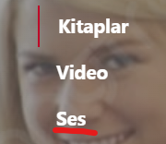 Ses Kayıtlar https://www.rhemaconnect.com/home/resources/book
 Ses Kayıtlar
https://www.rhemaconnect.com/home/resources/audio
 Ses Kayıtlar
https://www.rhemaconnect.com/home/resources/audio
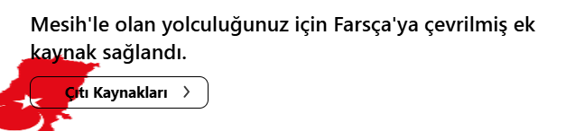
Mesih’le olan yolculuğunuz için Türkçeye çevrilmiş kaynaklar sağlandı.

Ek Kaynaklar
https://www.rhemaconnect.com/home/resources/book
 This picture needs to be changed as it is a political building and not appropriate for the website.
https://www.rhemaconnect.com/home/resources/book
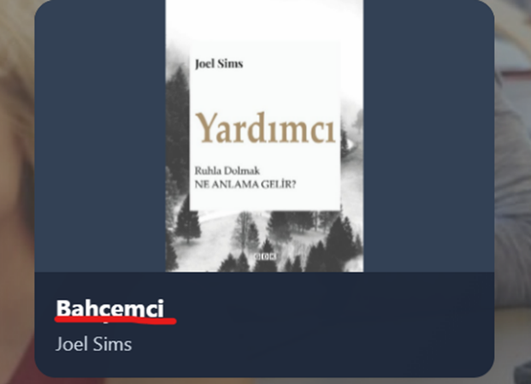 Yardımcı
https://www.rhemaconnect.com/home/resources/book

